Old Technology Sparks a New Interest in HVAC Industry

[HVAC Commercial Market](https://www.achrnews.com/topics/2683-hvac-commercial-market)[Boilers & Hydronics](https://www.achrnews.com/topics/2685-boilers-hydronics)[Chillers & Towers](https://www.achrnews.com/topics/2686-chillers-towers)

CHP: Old Technology Sparks a New Interest in HVAC Industry

These projects are sustainable in more ways than one

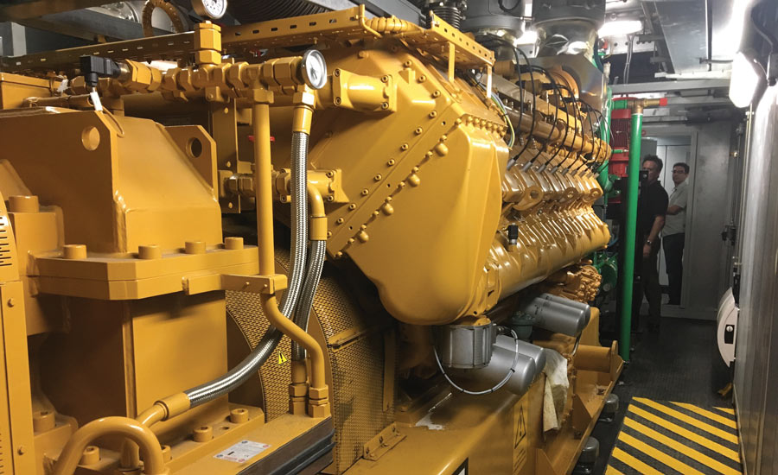POWERING THROUGH A CRISIS: A Matosantos Commercial Corp. processing facility in Vega Baja, Puerto Rico installed a 2 MW propane-fueled reciprocating engine CHP system in order to provide power as well as steam and hot water. During and after Hurricane Maria, the CHP system provided critical power and thermal energy for food processing and cold storage needs.

Call it [combined heat and power (CHP)](https://www.achrnews.com/keywords/1737-combined-heat-and-power-chp), call it cogeneration, call it something else. No matter the nomenclature, it has been around for quite some time now, and yet the pool of contractors who have worked on CHP projects remains comparatively small. There have been some decent reasons for that, but that list is getting shorter.

BOTTOM LINE AT THE TOP

A one-paragraph, simple overview of the basic CHP approach reads like this: A building’s (or campus’) system uses fuel to make its own electricity, and then it applies the waste heat from that process toward its HVAC needs. Benefits include significant savings on heating and/or cooling, reduced pollution output, and an independent electricity supply that can prove very valuable depending on the type of application.

Here’s how Marcia Karr, a professional engineer (P.E.) at Engineer in a Pocket LLP, puts it, having acquired substantial experience working on technology selection and proper sizing for CHP projects in multiple capacities over the years.

“For every $1 we put into energy, we normally get about 50 cents worth of work,” she said. “But, with CHP, that same dollar offers about 75 cents worth of work, thereby saving your customers about 25 percent on their utility costs.”

IS CHP A GOOD FIT?

It’s already obvious that while that ballpark of savings represents pretty strong street cred in terms of sustainability, CHP is not the average commercial HVAC job. The knowledge base required of a contractor working on CHP is a little different, too.

“A CHP/HVAC contractor needs to understand the importance and process of design build contracting versus typical bid work,” said Nolan Hill, CEO of Highland West Energy in Idaho Falls, Idaho. “Every project that we have been involved with has had a significant amount of engineering work or input. This means both providing information and system solutions to P.E.[s] in the engineering process and also during in the installation.”

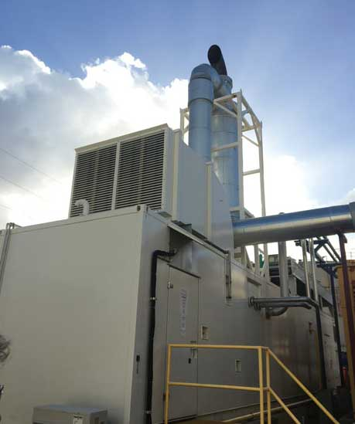CRISIS AVERTED: The Matosantos CHP facility was able to run independent of the grid for months after the storm because propane supplies were not interrupted. The facility has also been storing milk and other perishables for local plants.

Another type of experience will give a contractor a big leg up when it comes to CHP: electrical.

“Contractors willing to embrace CHP will find themselves working closely with their favorite electrical contractor,” Karr said.

CHP’s backup power capability dictates this; it requires selecting the loads to receive the backup power when needed and coordinating independent circuits from the CHP system to those loads.

Hill noted that a working knowledge with this and with engine operations can be learned over time, but the contractor must be willing to step into electrical and learn the basics.

Contractors who intend to work with owners in CHP will wind up going beyond the installation basics, according to Richard Sweetser. Sweetser is the founder and president of Exergy Partners in Herndon, Virginia, and he also works regularly with the Department of Energy on CHP-related projects.

According to him, standard variables that factor into decisions and designs are electric rate tariff structures, including commodity pricing, demand pricing, and standby charges.

Asked for the most common contractor mistakes seen in CHP projects, Hill cited not fully understanding the need for backup heat and water, along with details regarding the grid connection and how the utility functions.

For Sweetser’s part, he cited not matching the CHP system thermal capacity to the load properly.

“Contractors willing to embrace CHP will find themselves working closely with their favorite electrical contractor.”

— Marcia Karr professional engineer (P.E.) Engineer in a Pocket LLP

“A good CHP system must operate 85 percent of the time or more, delivering electricity and useful thermal energy.”

That leads to the broader question of which types of applications are best suited for CHP. The 85 percent figure and the required interest in some independent power availability may provide some clues.

“The best applications for CHP are those facilities with thermal loads all year,” Karr said. “Examples of the best commercial buildings include hotels, multifamily apartments, commercial kitchens, YMCA and health clubs with pools, and data centers with cooling loads all year. Having hot and/or chilled water loads all year allows for the maximum energy saving performance.”

TAP INTO PROGRAMS

For experienced contractors whose interest is piqued but whose readiness in this particular area has not peaked, assorted opportunities await and are getting better all the time. All the participants in this article concur that the DOE Technical Assistance Partnership (TAP) program can be an excellent resource.

Spread out as regional TAPs across the country, they are great at teaching the ins and outs of CHP development, Hill said.

“You can also glean information from the CHP Association ([www.chpassociation.org](http://chpassociation.org/)) and [EPA.gov/CHP](https://www.epa.gov/chp),” he added.

Sweetser recommends looking even closer to home. Utilities and state energy offices offer levels of information and organized CHP support that vary from state to state.

Reviewing a list of programs in Pennsylvania, for example, the resources are not necessarily just informational. That state’s list includes a special gas rate for CHP, a grant program, an efficiency rebate program, a specifically nonresidential efficiency rebate program, and a construction incentives program. Each of those is offered by a different utility or organization in the state.

CHP UPSIDES

At the end of the day, this sector is not for everyone; there’s more to know, more to consider, and the typical cost for a CHP system is, unsurprisingly, large. CHP contractors can’t have commitment issues, either, Hill said.

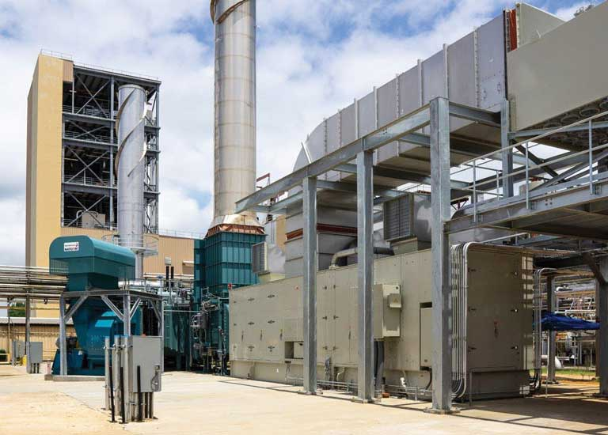EVERYDAY EFFICIENCY: This application will use natural gas to fuel a turbine to generate electricity, leveraging the exhaust heat from the turbine to produce steam. This production meets the entire steam demand for Shaw Industries’ carpet fiber plant in Columbia, South Carolina, and replaces the majority of electricity supplied by a utility company. PHOTO COURTESY OF SHAW INDUSTRIES

“The contract needs to consider the long-term maintenance aspect for the equipment,” he said. “This is not common in the HVAC contracting world. Standard warranties are one year but with no long-term maintenance contract. With CHP, you have to consider the long-term working relationship with the customer. If it’s managed right, then CHP will shine for both the customer and the contractor. If done wrong, it can really create a black eye on both the industry and the contractor.”

That, plus the technological involvement, can sound daunting on one hand.

On the other hand, unusually big-dollar projects, plus lasting customer relationships with associated ongoing revenue opportunities … not exactly the worst things that could happen to a business.

In addition, CHP delivers for the owners and the environment. Some of Hill’s customers are seeing 35 percent energy savings and over 50 percent reduction in CO2, NOx, and SOx emissions.

Of course, some contractors are currently doing this work with regularity. Sweetser sees certain areas of the country where HVAC contractors work on installations for smaller CHP projects (usually systems 100 kW or less). The occasional big project, too, although he does envision larger manufacturers getting more interested in expanding toward that type of work in the coming years. For the forseeable future, though, CHP remains a sector of business with plenty of room for contractors to get involved on different scales for a variety of possible applications.

Progress in packaged systems and more consistency in basic design from project to project should make it more attractive for those willing to make the leap and make a name in a growing niche of the industry.

From:https://www.achrnews.com/articles/139976-chpold-technology-sparks-a-new-interest-in-hvac-industry